From Pittsburgh To...
Interactive World Tourism Map
Web Development — Final Project Report

Lucas Havens, Nicolas Fiore, Aiden Patten | Indiana University of Pennsylvania

1. Project Overview
From Pittsburgh To...is a clickable world map web application that lets the user navigate to information about global travel and tourism. On a click of a highlighted country, a sidebar is opened that shows the distance from Pittsburgh, approximate one-way flight cost, approximate roundtrip cost, the number of tourists in 2024, total tourism spending, and the amount spent by each tourist. Python is used for data processing while HTML, CSS, and JavaScript are used for the front end.

2. Program Design

2.1 Architecture Overview
This is a static web application with a static data layer. All data are pre-computed in a python script before deployment, and run time js script read the data in JSON file. Since there is no database or backend, this is a very simple static web to host (GitHub Pages for example).

2.2 Technologies Used
Python / pandas — Data Processing
This data_format.py script contains all the pre-processing steps. This script reads three CSV source files using the pandas library; tourist expenditure, tourist arrival, and country coordinates. These three sources are then joined by the country code and the year, and filtered to the year 2024. It computes the average spending per tourist, the distance between the center of each country and Pittsburgh, PA (40.4406, -79.9959) using Haversine formula to determine the great circle distance, and the round-trip and one-way flight costs based on a fee and cost per mile. The output is then stored in full_data.json and indexed by the country's ISO code. This is the file used by the browser to display data.
HTML5 — Structure
The index.html file dictates the structure of the page. It contains a static header with the name of the project and a clue about how to use it. Underneath the header, it consists of a two-column layout for the page contents. The left column is the container for the map while the right column is an info panel sidebar. This sidebar includes a region that will store the country shape display, the name of the country and a button to close it and several labeled stat lines to be populated dynamically by the JavaScript code when a country is chosen.
CSS3 — Styling and Layout
The style.css file contains the styling for the entire project with an off-white color theme (background #f4f0e8) and the deep red #7A1706 color reflecting the travel theme. This project uses flexbox to create a responsive interface. Display: flex is used throughout to ensure the map and sidebar occupy space next to each other, and to expand to fill remaining space. The map path elements use fill rules with 3 color states; the countries that do not have data are grey by default. Those that do have data have a fill rule with the color deep red (has-data), the selected country has the color blue (selected). The sidebar is hidden by default (display: none) and displayed using the JavaScript class.
JavaScript (Vanilla) — Interactivity
The script.js file, as expected, is responsible for all client side interaction, and all the interaction is initiated from a single async build() function. At the beginning of the build(), it uses Promise.all() to request and retrieve both full_data.json and world.svg simultaneously. The markup for the SVG is inserted directly into the map container div and its viewBox and preserveAspectRatio properties are set dynamically, so the map is displayed correctly at any size the browser window is. Then, the script iterates through each country code in the data object and adds a has-data class to the corresponding SVG path, in the world SVG. Event listeners are added for clicks on all SVG paths, so if a has-data SVG path is clicked, it displays all previous selections and sets the clicked path's class to selected, then populates the sidebar with the values in the clicked country's data. The script also clones the clicked SVG path into a separate, inline SVG element whose height and width are equal to the width and height of the bounding box containing the country shape, and places it in the panel, as a preview of the country's shape. The close button sets display: none on the panel and clears the selection.
SVG — World Map
The world map is generated using an SVG file, where each country is defined as a <path> element, with the corresponding ISO 3166-1 alpha-2 country code as the id of the element. This way it is possible to directly correlate the entries in the JSON data with the elements of the SVG map based on the Country Code. Using an inline SVG instead of a raster image lets CSS and JavaScript interact directly with the paths: you are able to define them, assign individual styles, and attach event handlers.

3. Data Sources
The following datasets from Our World in Data (UN Tourism) were used:
- Tourist spending — international visitor spending per country (2024)
- Tourist arrivals — international tourist trips per country (2024)
- Country coordinates — centroid latitude/longitude per country for distance calculations

4. Screenshots
The following screenshots demonstrate the project running in a web browser.
Figure 1 — Home view (no country selected)

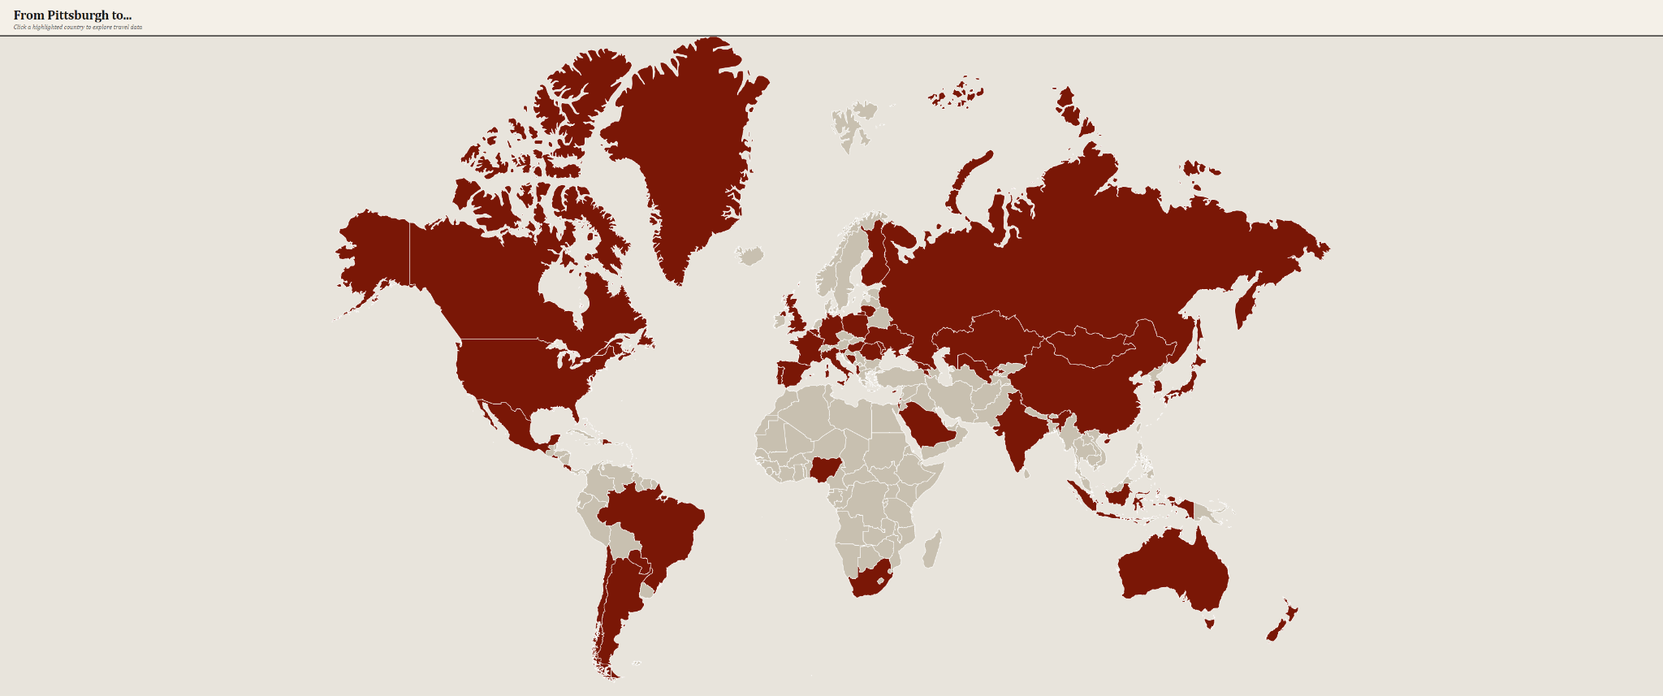

Figure 2 — Country selected with info panel open

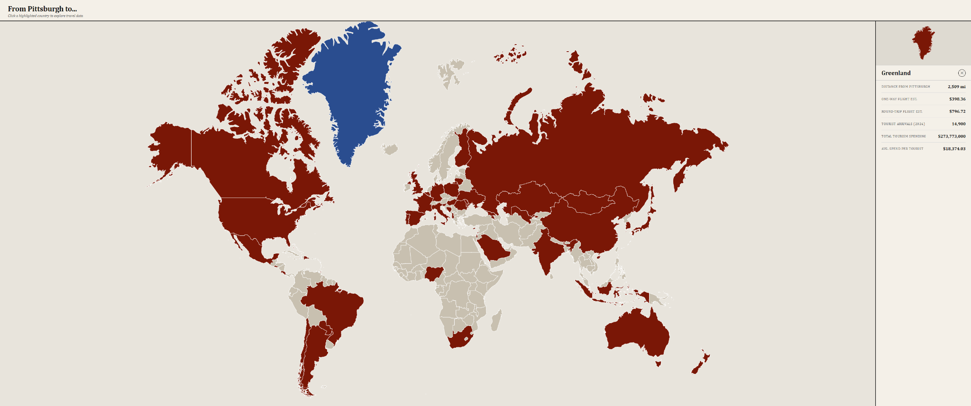

Figure 3 — Close-up of the info panel stats

